**Introduction to Object Oriented Programming (OOP)**

Erwan Majid/08/2i

**Experiment Activity 1**

Sepeda:

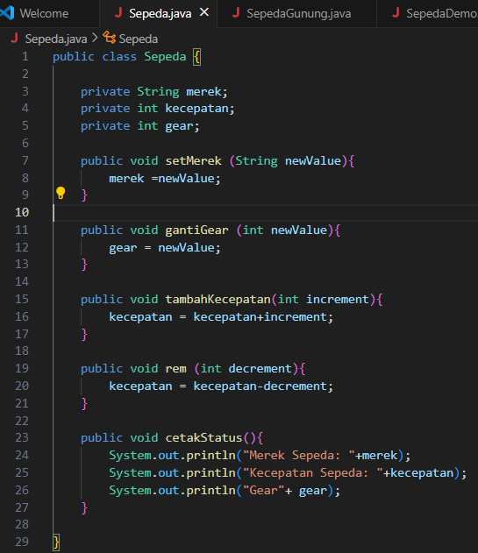

Sepeda Demo:

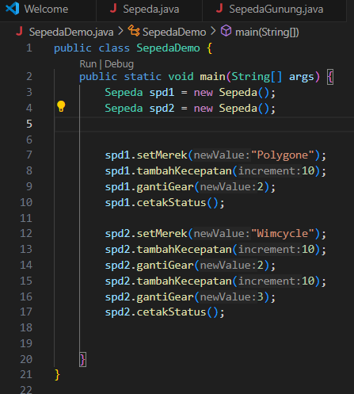

Result:

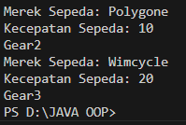

**Percobaan 2**

SepedaGunung:

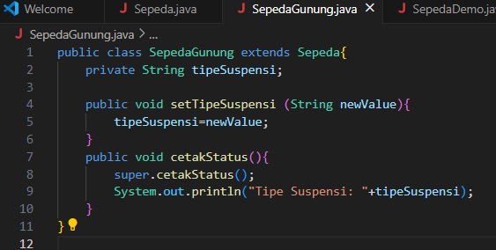

SepedaDemo:

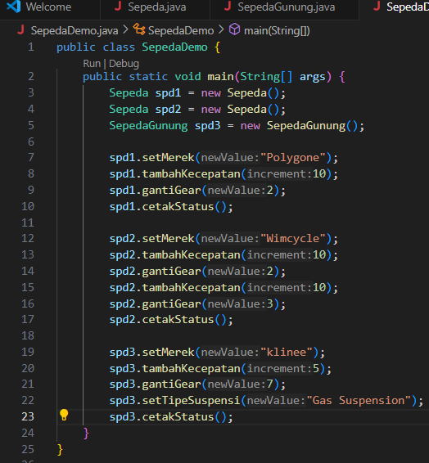

Result:

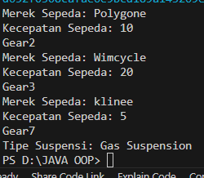

**5. Question Test**

1. Explain the difference between object and class!

- Classes are used to define the structure and behavior of objects, while objects are used to represent specific entities in a program.

2. State your reason why color and engine type can be classified as attribute for car object!

- Color and engine type are attributes because they have unique aspects of a car object that contribute to its overall state, appearance, and behavior. They help in differentiating one car object from another, making them essential parts of the object's identity.

3. State one of OOP better point than procedural programming

-Encapsulation is a key advantage of OOP over procedural programming. It bundles data and methods into objects, protecting the data from unintended changes and promoting modular, maintainable, and reusable code.

4. Is it allowed to define two attributes in one line code such “public String nama,alamat;”?

- Yes, it is allowed in Java to define two attributes in one line ,for example public String nama, alamat;

5. In SepedaGunung class, state your reason why merk, kecepatan, and gear attributes are not

written again in this class!

- merek, kecepatan, and gear are inherited from the Sepeda class, so there’s no need to redefine them in SepedaGunung. because they are inherited from the Sepeda class, which SepedaGunung extends.

**6. Assignment**

1. Follow these instructions to make your practical assignment is performed systematically:

a. Take 4 photographs of objects around you, 2 objects must be implementation of inheritance

concept, example: refrigerator, chair, living room table, desk! As we know that living room

table and desk are inherited by table class.

- TVLED and TVTabung are subclasses that inherit from TV

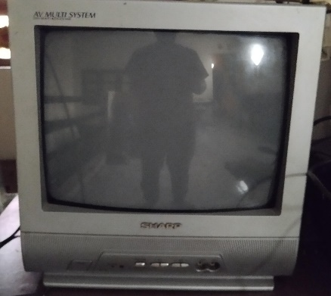  
  
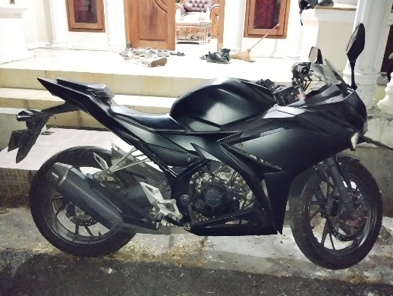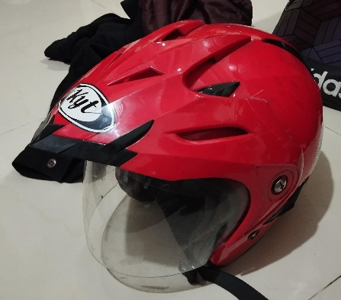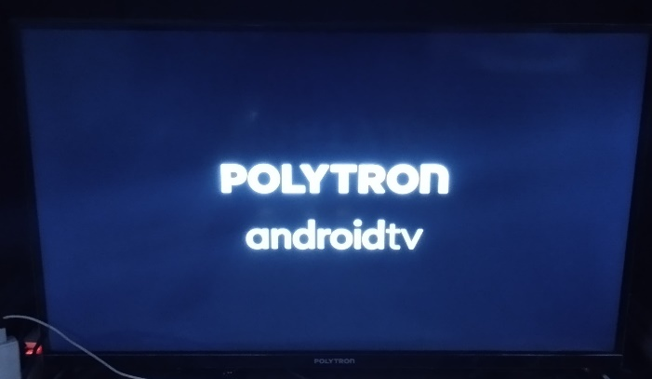

b. Observe those objects to define the attribute and method!

**-Tv Led**

Atribut:

brand: Polytron

screenSize: 43 Inch

resolution: 4K

OS:Android

Memory:4GB

method:

turnOn():

turnOff():

changeChannel(int channel)

displayInfo()

-**TvTabung:**

Atribut:

brand: kaori

screenSize: 12 Inch

resolution: 480

Tube Diameter: 81 inches

Production Year : 2004

method:

turnOn():

turnOff():

changeChannel(int channel)

displayInfo()

-**Sepeda Motor:**

Atribut:

brand: Yamaha

machine:150cc

silinder:2

Production Year : 2018

method:

startengine();

stopengine();

accelerate();

displayinfo();

-**Helm:**

Atribut:

brand: KYT

glass: clear

size:L

method:

displayInfo()

public void adjustStrap()

public void cleanGlass()

public void putOn()

c. Convert those objects into four classes in Java programming!

-TvLed

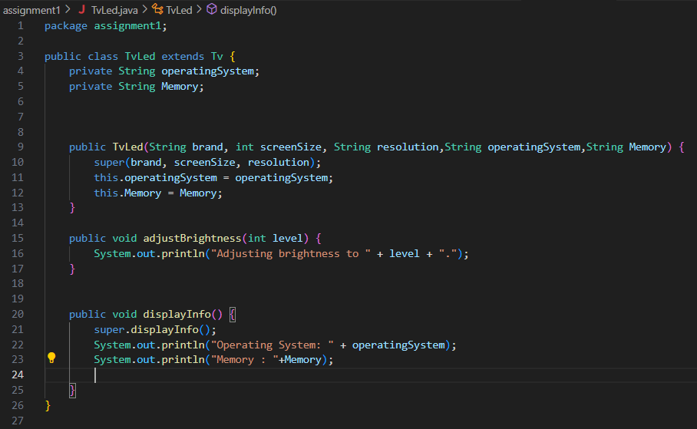

-tv Tabung:

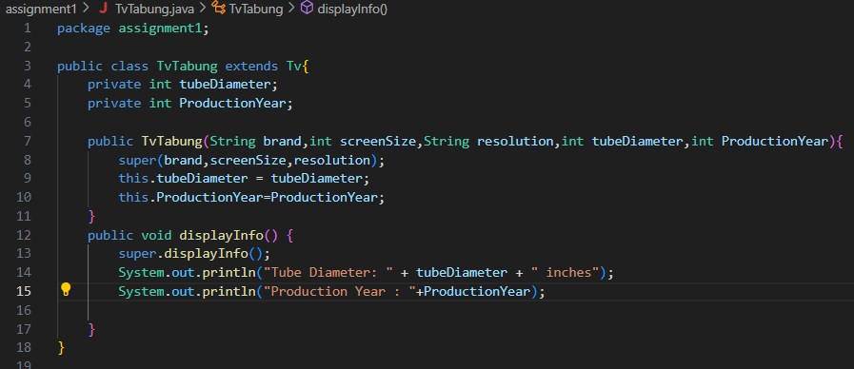

-Motorcycle:

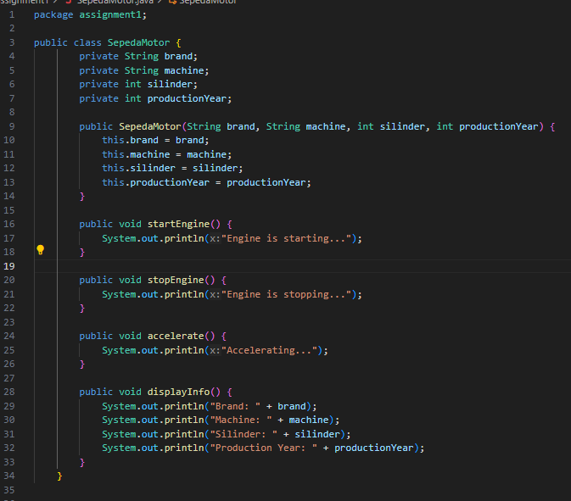

-Helm:

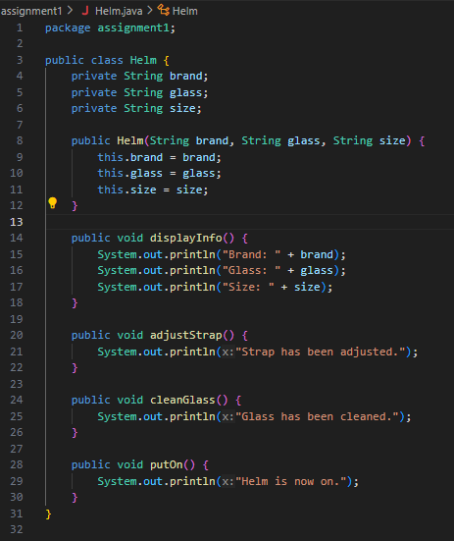

d. Add one additional class as a class which inherits its attribute and method to living room

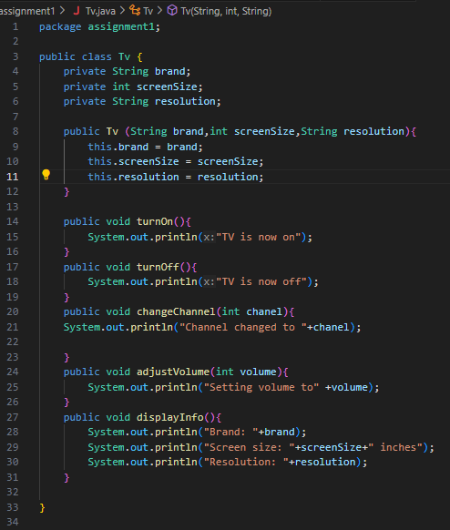table class and desk class!

-

e. Add two attributes for each class!

-Helm:

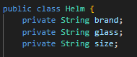

-Motorcycle:

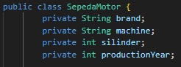

-Tvled:



-TvTabung:



f. Add three methods for each class including a method for showing the information!

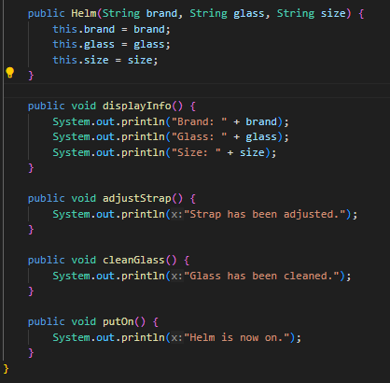-Helm:

Motorcycle:

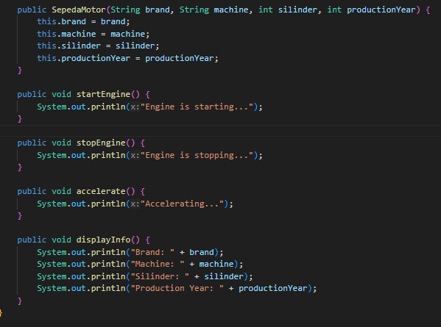

TvLed:

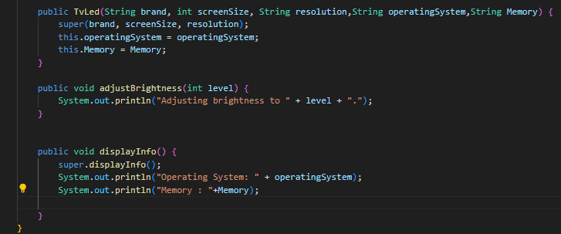

tvTabung:

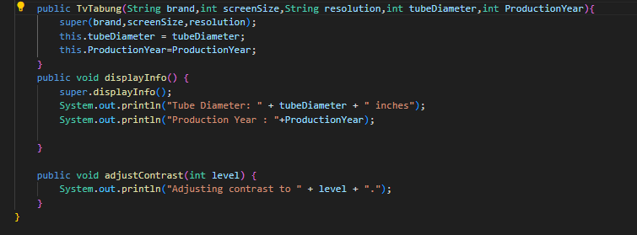

g. Add one class named Demo for main class!

-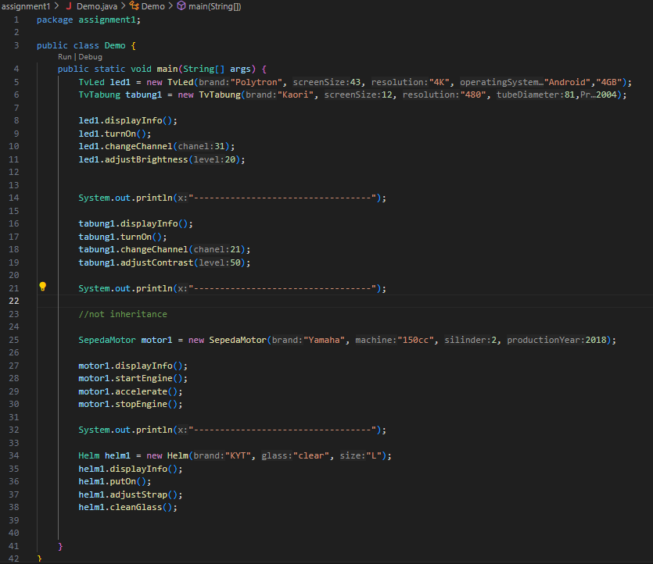

h. Instance an object for each class!

i. Apply each method for each object in main class!

j. The example which is mentioned in point 1.a should not be included in your task